**GROUP 8:**

**BAGADIONG**

**FAJARDO**

**MACHINE PROBLEM #1 (MATLAB SOLUTION)**

**Test:**

No user input

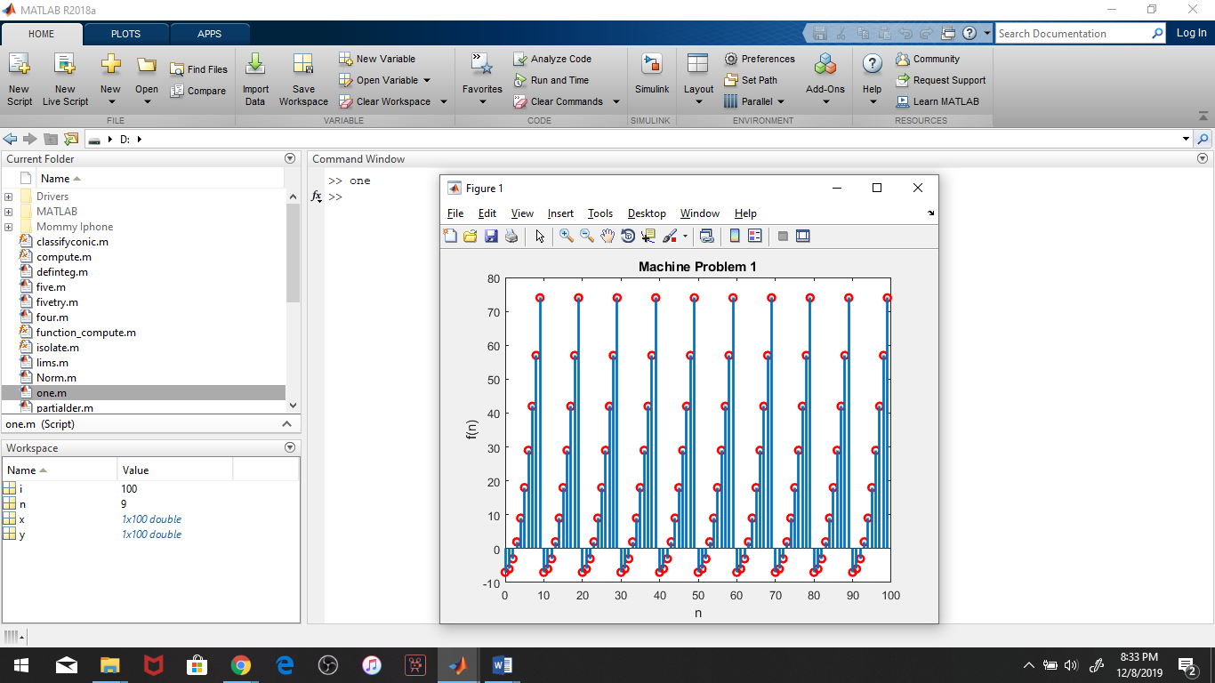

The graph of f(n) is identical for every interval of 10 points in n. f(n) is negative when n = 0, n = 1, and n =2. The graph is identical for every interval of 10 points since when n is equal to or greater than 10, a value of 10 is subtracted from it, which is then assigned to n, the values being 0, 1, and 2 consecutively.

**Script file:**

